

Data Warehousing & Business Intelligence (IT)

3rd Year, 1st Semester

# Assignment 2

Submitted to

Sri Lanka Institute of Information Technology

IT20035358

K.N.N.D.S Jayarathna.

Weekday Batch

**Step 01 - Data source selection**

* The data warehouse that was previously imported in Assignment one is the data source for 2nd Assignment.
* One Fact Table and five Dimension Tables are included.
* The Snowflake schema is used to organize the tables.
* DimItem - contains details of all the Item details, the Bran Types, Categories and Brands as well as the insert and modified dates.
* DimCustomer - contains all the customer data, their IDs, their income bracket, family size, marital status, no of children, if the house is rented and age range. And insert and modified dates.
* DimCouponRedemption - coupon redemption contains information about all coupons provided, including the campaign to which they belonged, their redemption status, and the client to whom they were offered. It also joins the DimCampaign table with a foreign key.
* DimCampaign - provides information about all the campaigns that offered customers coupons to redeem. It includes the campaign date, start and end dates, as well as the campaign id.
* DimDate - includes date dimension
* FactCustomerTransaction table - includes all of the customer's transactions,It has surrogate keys for all the Dimension tables that are connected.It also has a Date key, which is linked to DimDate's date key.

* First, I created new SSAS project and named it as CouponRedemption_Analysis. The data warehouse was renamed DS_Coupon Redemption DW.ds loaded as the data source.
* The Snowflake schema that was created is shown below.

**Step 02 -Cube Implementation**

* Before implement the Cube I implemented the data source view. It named as DSV_Coupon RedemptionDW.dsv.
* Data warehouse was used as the data source as mentioned.
* The tables were then finished by joining the surrogate keys in the Fact table to the surrogate keys in the dimension tables, and the table structure was finalized after connecting all the essential components.
* The table structure can be seen in the image below.

* After the Data Source view was created a cube was created. The cube was named CUBE_Coupon Redemption Dw.Cube.

* All keys were properly mapped as follows.

* Hierarchies were created to identify levels between relationships.
* Hierarchies were created for Items as well, considering their Brand, Brand Type, and the Item Categories.

* To map the dates and construct a flow of Year-Month-Date, date hierarchy was created.

* These hierarchies were utilized to determine drill down, roll up OLAP operations.
* Sql Server Management Studio was used to connect to the Analysis Service, and the cube was then deployed.
* There were mistakes that happened throughout the deployment of the cube before it was successfully deployed, and all the errors were corrected.
* After the cube was successfully deployed, data browsing was enabled in Visual Studio Data Tools and SQL Server Management Studio, as shown below.

* **Key Performer Indicator**
* Graphical user interface, application

  Description automatically generatedI have created KPI final Price. It is very important to the system to for determining how many customers purchased selling price more than 100 and which type of Items related to that price.
* The results of analyzing the KPI Selling Price against Brand Type and Category of an Item, as well as the month name, are shown in the image below.

**Step 03 -OLAP operations**

* Online Analytical Processing can be done by connecting to Excel. It provides us a platform to give graphical as well as tabular representations of our data that we have in our cube. Reports were created using Excel by both methods, by connecting to Excel without MDX queries, where we were able to obtain all the table and using MDX queries, where selected tables were obtained.
* **Drill Down and Roll up**

* The above screenshot shows an analysis in which we were able to compare the sum of Selling Price, and sum of quantity the items available by Brand Type, Brand and Category. We were able to analyze the variances in the values by drilling down from Brand Type, Brand and category of the items and here I used the Month name to analyze sum of selling price and quantity month wise.

Graphical Representation

Selected proper dimension tables, also selected measures from the FactcustomerTransaction Table and Drag and drop that fields into proper coloumns, Rows and values to implement the Drill down and roll up operations.

* **Slice**
* I have sliced my data set according to the Established and Local BrandTYpes.

Slicing data according to the establish brand type

Slicing data according to the local brand type

Graphical representation of slicing with local brand type

Graphical representation of slicing with establish brand type

* **Dice**

Here I used both DimItem and DimDate table,From DimItem I used BrandType and DimDate table I used Month Name to filter the data.

* **Pivot**

From the implement cube I implemented the above pivot table.

**Step 04 - SSRS Reports**

* First, I connected to the SQL reporting service configuration, the report builder was used to create reports. It was used to create number of reports.
* Then I started creating reports by specifying a data source source and then writing Query to retrieve reports.

1. **Report with Matrix Report**

I used to Dim Item table and fact customer transaction table to analyse the brand wise transactional details. Here I hope to analyse how the customer had made the purchase and quantity of a certain brand types and brand, and here each brand of bardtype was analised separately for the months February and January.Also we looked at all the brand in the Established and Local Brand types.

Above two images show the matrix report of analysing Brand-wise transactions.

1. **Report with more than one Parameter**

More Than one Parameter based on Brand and Brand Type

One of the most important studies required by this organization is to examine the discounts and determine whether they are used, as well as to determine which brands the consumer uses the discounts on. This report offers multi-valued parameters, such as the ability to filter by Item Brand Type to see all of the Brands that fall under it.

1. **SSRS Drill Down report**

* To create the drill down Report I used Brand,BrandTypes and Categories. All categories are under the Brand and all Brands are under the Brand Types. We were able to analyze the variances in the values by drilling down from BrandType, Brand and category of the items.

Item performance under the Established

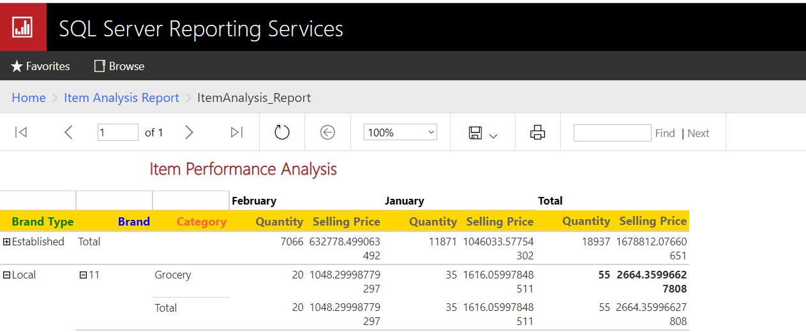

Item Performance Analysing under the Local BrandType.

1. **SSRS Drill Through Report**

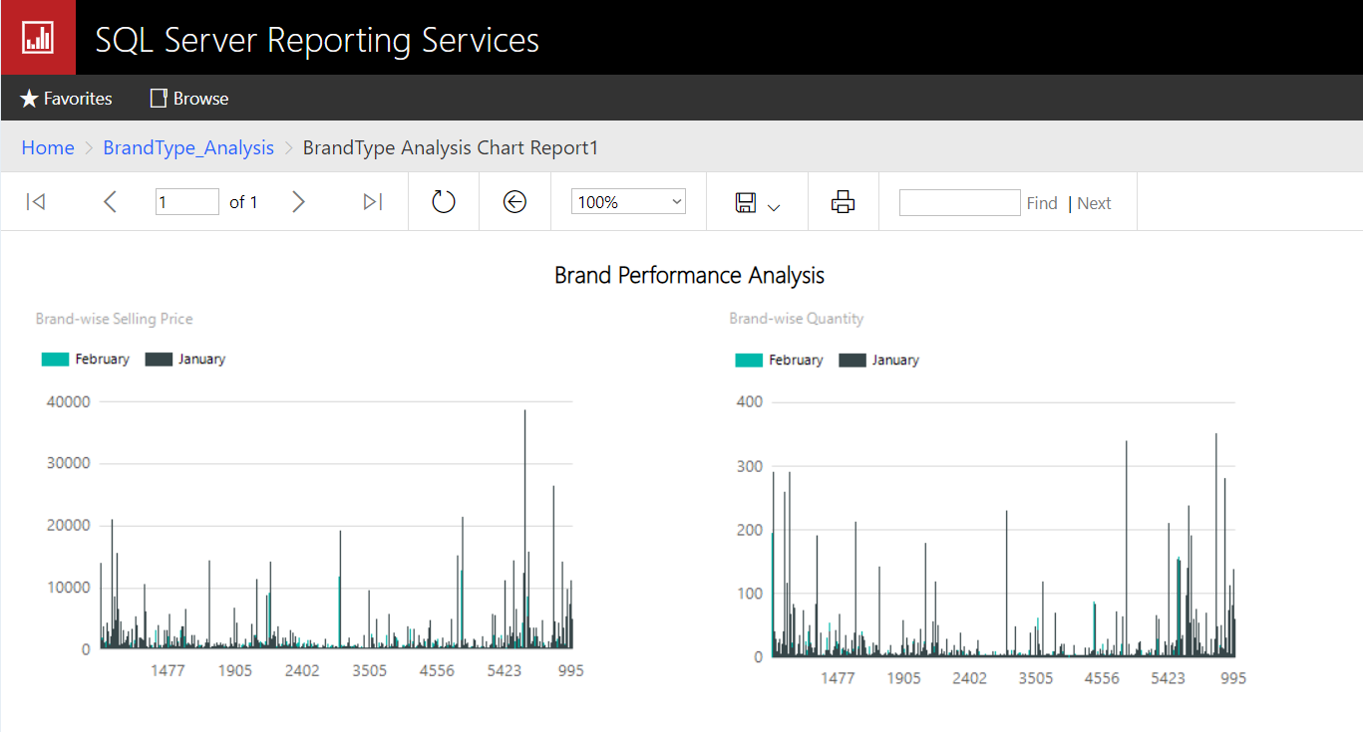

Above images shows the drill through Report.

* First, I created the BrandType Performance Analyse Report, using that we were able to drill through the Brand performance Analysis Report as well.